Setup OpenSSO for the CONNECTUniversalClientGUI
Overview
OpenSSO, an open source access management project, is used in conjunction with OpenDS to authenticate and authorize users of the CONNECT GUI’s. OpenSSO provides authentication services to the CONNECTUniversalClientGUI and ConsumerPreferencesProfileGUI applications by enforcing Single Sign-On (SSO) access control.
Before installing OpenSSO for use with the CONNECTUniversalClientGUI, please ensure that you have successfully installed and configured OpenDS for use with the GUI.
Prepare System for OpenSSO install
The following instructions demonstrate how to install and configure OpenSSO v2.2.1 on a Windows based machine:
- Move and upgrade the openssoclientsdk.jar from the Appserver lib directory to the domain lib directory by following these steps (Note: if your CONNECTCoreLib.jar and CONNECTCommonTypesLib.jar files currently reside in the Appserver lib directory, also move them to the domain lib directory):
- If it’s currently running, stop Glassfish “domain1”
- Using a Windows directory browser, go to \Oracle\glassfish\lib and delete the openssoclientsdk.jar file
- Copy the openssoclientsdk.jar file from the \Projects\NHINC\3.3.1\ThirdParty\OpenSSO\Installation_Files directory to the \Oracle\glassfish\domains\domain1\lib\ext directory
- Start Glassfish “domain1”

- Create a new Glassfish domain for the OpenSSO install by following these steps:
- Open a command window and navigate to the \Oracle\glassfish\bin directory
- Enter the following command:
asadmin create-domain --user admin --portbase 2000 --savemasterpassword domain2

Set the admin password and master password to “adminadmin” when presented with the following prompts:

Please enter the admin password>adminadmin (enter)
Please enter the admin password again>adminadmin (enter)
Please enter the master password [Enter to accept the default]:> adminadmin (enter)
Please enter the master password again [Enter to accept the default]:> adminadmin (enter)

If the creation of the new domain is successful, you will see output similar to the following in the command window:

Using port 2048 for Admin.
Using port 2080 for HTTP Instance.
Using port 2076 for JMS.
Using port 2037 for IIOP.
Using port 2081 for HTTP_SSL.
Using port 2038 for IIOP_SSL.
Using port 2039 for IIOP_MUTUALAUTH.
Using port 2086 for JMX_ADMIN.
Domain being created with profile:developer, as specified by variable AS_ADMIN_P
ROFILE in configuration file.
Security Store uses: JKS
Domain domain2 created.

- Start the newly created domain2 by entering the following command:
asadmin start-domain domain2
Note: to tail the log in the command window, add the --verbose flag before “domain2” in the command above
Deploy and Configure OpenSSO

The steps below walk you through the process of installing and configuring OpenSSO on the domain that was created in the preceding section. The new domain (domain2) uses port 2048 for the admin console port, 2080 for the non secure http port and 2081 for the https port.

- Deploy OpenSSO to domain2 by following these steps:
- Open a web browser and navigate to the domain2 admin console via the following URL:

http://localhost:2048

- Login with the username of “admin” and the password “adminadmin”
- Click “Web Applications” on left-hand side of browser window
- Click “deploy”
- Click the “browse” button, navigate to the \Projects\NHINC\3.3.1\ThirdParty\OpenSSO directory, and then select the opensso.war file
- Click “Open”
- Click “Ok”

If the install was successful, you will see opensso listed in the “Web Applications” table.

- Configure the OpenSSO install by following these steps:
- Open a web browser and navigate to http://localhost:2080/opensso
- Click the “Create Default Configuration” link:

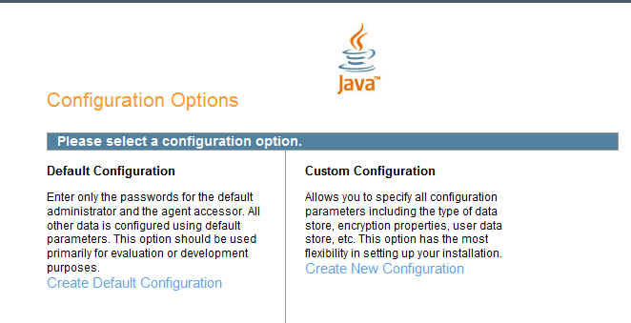

- Enter and confirm the password for amAdmin by entering “adminadmin” for both the password and confirm password
- Enter and confirm the password for UrlAcessAgent by entering “adminadmin1” for both the password and confirm password

- Click “Create Configuration” button
- Click the “Proceed to Login” link to continue

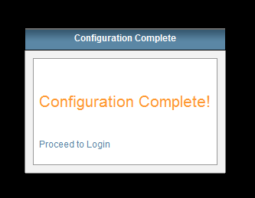

Create an OpenDS User Data Store in OpenSSO
The steps outlined below create an LDAP v3 data store within OpenDS that points to the OpenDS instance that was configured in the preceding steps.
- If not already logged into OpenSSO, open a web browser and login to the OpenSSO administration console by navigating to by navigating to http://localhost:2080/opensso:

- Enter the User Name “amAdmin” and the password “adminadmin” when presented with the login screen
- Click the “Access Control” tab
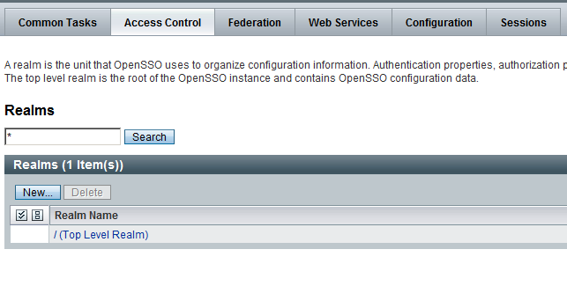

- Click the “/ (Top Level Realm)” link

- Click the “Data Stores” tab

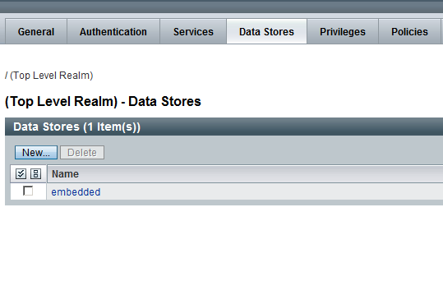

- Click the “New…” button

- Name the Data Store “OpenDS User Store” and then select the “Sun DS with OpenSSO schema” radio button. Click the “Next” button.

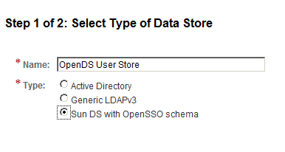

- Make the following changes to the New Data Store – Sun DS with OpenSSO schema screen:

- LDAP Server – remove the current value of “localhost:50389” and add a new value of “localhost:389”
- LDAP Bind DN – change the value to “cn=Directory Manager”
- LDAP Bind Password – enter “adminadmin”
- LDAP Bind Password (confirm) – enter “adminadmin”
- LDAP Users Search Attribute – change the value to “cn”

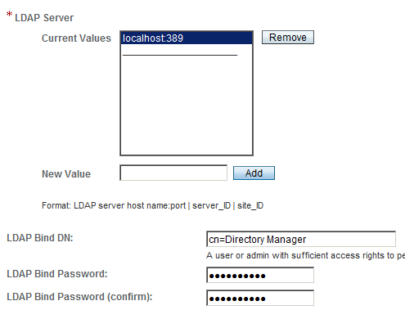

- LDAP User Attributes – add the values “o”, “businessCategory”, “employeeType” and “carePortalId” to the list of values

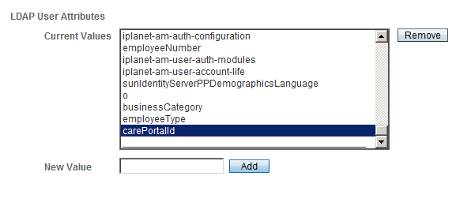

` Once all of the values have been changed, click the “Finish” button.
button.

- Select the “Subjects” tab. You should see an entry for "testuser” in the “Users” table as depicted in the following screen shot:

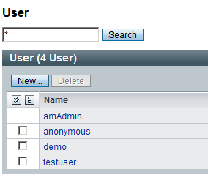

- If the configuration was successful and you’re now able to see OpenDS users from within the OpenSSO console, then the default OpenSSO data store can be deleted by clicking on the “Data Stores” tab, selecting the “embedded” Data Store from the “Data Stores” table, then clicking the “Delete” button.

Successful deletion of the default Data Store should result in a message that reads “Data
Store has been deleted”

Configure CONNECT to use OpenSSO Authentication
- Locate the /Sun/Appserver/domains/domain1/config/nhin/AdapterAuthenticationProxyConfig.xml file and open it in a text editor

- Use the OpenSSO implementation by setting the id=”adapterauthentication”

<!-- AdapterAuthentication java implementation Uses the OpenSSO authentication services -->
<bean class="gov.hhs.fha.nhinc.adapterauthentication.proxy.AdapterAuthenticationJavaProxy" id="adapterauthentication" name="adapterauthenticationjava">
<meta key="impltype" value="java"/>
</bean>

- Change the id value for the NoOpImpl entry (the bean entry in the file) to “adapterauthenticationnoop”

- Save the AdapterAuthenticationProxyConfig.xml file and then restart Glassfish domain “domain1”

- When the Glassfish domain has restarted, you can now test the authentication functionality. To test OpenSSO authentication with the CONNECTUniversalClientGUI, follow these steps:

- Open a web browser and navigate to one of the following MIDHT GUI’s:

http://localhost:8080/CONNECTUniversalClientGUI

OR
http://localhost:8080/CONNECTConsumerPreferencesProfileGUI

- When presented with the login screen, login with the username of “testuser” and the password of “password”
- If successfully logged-in, click the “Log out” button
- Attempt to login again using a bad user name and password combination and ensure that the GUI will not grant you entry.

OpenSSO is now installed and configured to authenticate and authorize GUI users that are stored in the OpenDS LDAP.

